SOPHOMORE YEAR ACTION PLAN
Northgate High School 2018-19
https://northgatehighschool.org
College & Career Center

Tips:
- Get good grades…Colleges look closely at 10th and 11th year grades. Colleges will accept you based on your GPA at the end of junior year. They will keep you based on your senior grades.
- Having trouble in a class? Talk to your teacher about getting help. Don’t wait until you fall far behind.
- Don’t get any D’s or F’s. It is very difficult to make them up. If you do get a D or F, see your Academic Counselor (A-G=Ms. Saremi, H-O=Ms. Bligh (Ms. Dobbs SUB), P-Z= Ms. Kaur).
- Take AP & Honor’s classes only if you think you can get an A and it is a subject that you really like.
- Choose colleges that fit YOU. Don’t choose colleges by name. You, not a college, have the power to achieve success.
- Teachers will need to write college recommendations for you. Get to know them now. Participate in class, show interest in the subject, ask questions, show good work habits, show integrity and initiative, and be collaborative. Teachers are asked to rate you on these and other characteristics.

FALL SEMESTER:
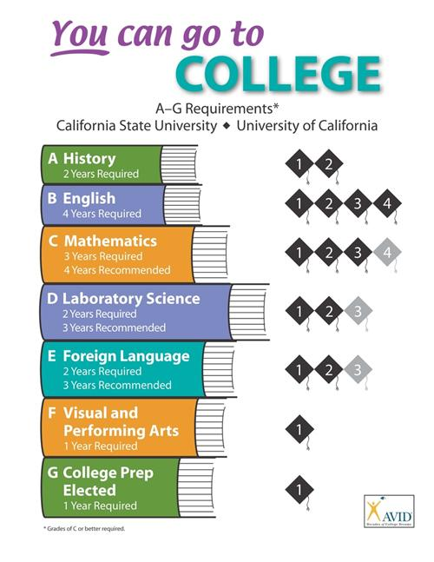

September/October:
- Revisit your 4 year plan. Make sure that you are on track to complete the A-g’s!
- Discuss with your parents how much money they can afford to provide for your college education. Know your budget.
- Continue working on community service and extra-curricular activities.
- Check Naviance for colleges visiting Northgate. Meet the college reps who actually read applications. Ask questions about specific schools.
- Attend the District College Fair at Ygnacio Valley, Oct 23 @ 6:30-8:30pm.

November/December:
- Explore Careers: In Naviance, go to “Careers” and take the Career Interest Profile and the Personality Type assessments.
- Explore Colleges: In Naviance, go to “Colleges”, then to “Colleges I’m Thinking About” and add colleges that may interest you. Go to “Super-Match” to search for specific colleges that match your grades, scores, where you want to live and major.
- Study for finals…do well!
- Visit colleges over the break, if possible.

SPRING SEMESTER:

January:
- Work on your course schedule for your junior year.
- Continue to use Naviance Student
- Start thinking and researching summer classes, seminars, jobs, etc.

February:
- Finalize your list of classes for your junior year. Talk to your teachers and Academic Counselor if you are not sure if you should take the next level class.
- Work on your resume in Naviance Student (located in “About Me”) and start investigating summer jobs.

March/April:
- Take the PSAT 10 exam at NHS (every Sophomore will take this). It’ll help you learn how ready you are for the PSAT/NMSQT and SAT college entrance exams.
- Work on college list and/or post-high school plans.
- Visit the College & Career Center for guidance.
- Sign up for AP tests, if necessary. (online registration info coming)
- Visit colleges over the Spring Break.
- Attend local College Fairs (see the College & Career Center Calendar).
- Study for AP exams.

May/June:
- Take AP tests
- Study for finals…do well!
- Start on the “Personal Data Form” on Naviance - necessary for teachers and counselors who write your college recommendations.
- Add to your college list
- Plan to visit colleges over the summer.
- SAVE THE DATE: PSAT, Sat., Oct. 19th , 2019
If you score well, you can qualify as a National Merit Scholar and be in the running for their scholarship
