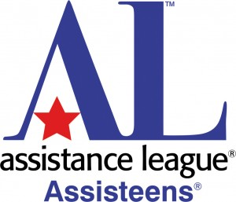
Join the Assisteens Auxiliary of Assistance League of Diablo Valley

Interested in helping your local community?
Assistance League of Diablo Valley is a nonprofit, member volunteer organization dedicated to improving lives in our community through hands-on programs.
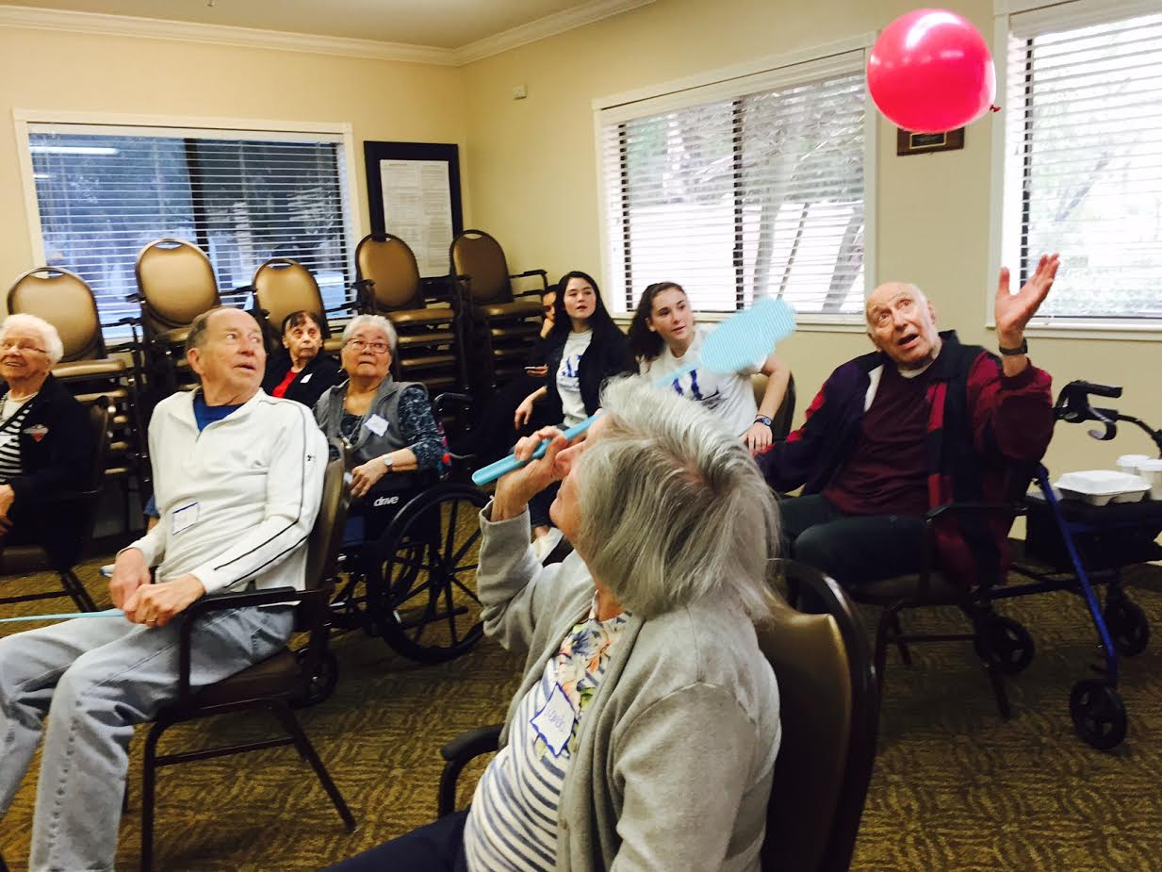
- Assisteens is accepting applications for young men and women who will be entering grades 7 through 12 in the fall of 2018-2019.

- Membership is limited to 60. Membership dues are $35 plus a T-shirt fee.

- Final date for acceptance of new members is September 30 or upon maximum enrollment of 60.

For more information, please contact:

Assistance League of Diablo Valley
2711 Buena Vista Avenue
Walnut Creek, CA 94597
925-934-0901
aldv@sbcglobal.net
Website: http://www.diablovalley.assistanceleague.org

